Firebrand flux

186 m

0 m

320 m

FBP X

FBP Y

FBP Z

FCS X

FCS Y

FCS Z

Fire line

Road

320 m

160 m

300 m

250 m

150 m

100 m

50 m

Case A: 2 m

Case B,C: 7m

Pineland National Reserve prescribed burning (Filkove et al.)

1. Increasing the Fireline depth

|  |  |  |  |  |  |  |
| --- | --- | --- | --- | --- | --- | --- |
| Case | Firebrand initial  Temperature  (0C) | Particle velocity  (U,V,W) m/s | Ember input rate pcs/s | Flux (pcs/m2/s) | | |
| FCS Z | FCS Y | FCS X |
| **A**:depth 7m | 900 | (8.3, 0.0, 2.1) | 11 171 | 1.375 | 1.082 | 0.870 |
| Experiment | NA | NA | NA | 1.335 | 0.902 | 0.824 |
| Difference (%) | | | | -2.0 | 16.7 | 5.3 |

|  |
| --- |
| Landing firebrand flux vs size comparison of the experiment and the simulation -  (fireline depth 7m and Firebrand temperature T=900 0C). We assumed the densities of firebrands change during the flight due to moisture evaporation and pyrolysis. The density variation in terms of % of initial density were taken again from IMFSE thesis (see page 66 Fig. 30) and our firebrands densities were adjusted according to that. |
|  |

Firebrand input rate (Case B and C) = 11 171 pcs/s

Average HRR = 2672 MW

Firebrand generation rate =(11 171 pcs/s)/(2672 MW)

=4.181 pcs/MW/s

AS3959

Case: ForestFDI100BAL12.5

|  |
| --- |
| Firebrand flux on specific locations |
| Firebrand flux on vertical planes at different x directions |
| Firebrand flux on the floor at different x directions |
| Radiative heat flux on specific locations of the house |
| Convective hat flux on specific locations of the house |

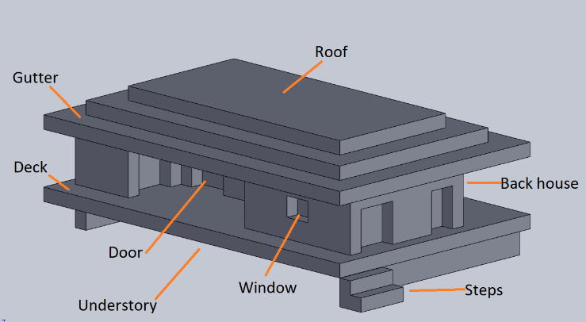

|  |  |  |
| --- | --- | --- |
| Forest FDI 100 | | |
|  | Given in the standard | House located at (mid value of the standard) |
| BAL 12.5 | (48 =<100) | 50 m |
| BAL 19 | (35 =<48) | 41 m |
| BAL 29 | (25 =<35) | 29.75 m |
| BAL 40 | (19=<25) | 21.5 m |
| BAL FZ | (<19) | 9.5 m |

Grass fire simulations

Heat flux devices locations

|  |  |
| --- | --- |
| Device ID | Location |
| RF1, CF1 | Roof front right (close to the mirror boundary) |
| RF2, CF2 | Roof front left (away from the mirror boundary) |
| RF3, CF3 | Base front right (close to the mirror boundary) |
| RF4, CF4 | Base front left (away from the mirror boundary) |
| RF5, CF5 | Sub-floor front (close to the mirror boundary) |
| RF6, CF6 | Roof top front (close to the mirror boundary) |
| RF7, CF7 | Roof top front (away from the mirror boundary) |
| RF8, CF8 | Roof top middle (top position: close to the mirror boundary) |
| RF9, CF9 | Front wall |
| RF10, CF10 | Door |
| RF11, CF11 | Back wall right side (close to the mirror boundary) |
| RF12, CF12 | Back wall left (away from the mirror boundar) |
| RF13, CF13 | Sub floor middle (inside the subfloor area: close to the mirror boundary) |
| RF14, CF14 | Side wall bottom |
| RF15, CF15 | Side wall middle |
| RF16, CF16 | Side wall top |

|  |
| --- |
| Front side devices |
| Back and side walls’devices |

|  |
| --- |
| C1_as3959_u12p5_rh25_f00045_t39_fdi100  Radiative and convective heat flux (Averaged) |
| C1_as3959_u12p5_rh25_f00045_t39_fdi100  Radiative and convective heat flux (Averaged) ---- > doubling the HF near mirror boundary |